Scheme Implementation system of choice:
- Racket – a multi paradigm language platform
  - previously PLT Scheme
  - Racket version 8.x
  - Language:
    - #lang racket
or
    - Pretty big (auto import of many useful modules)
- URL: http://racket-lang.org/

The Basics:
  - Developed at Rice Univ.
- Two windows:
Upper: definition window (define or load procedures)
Lower: interactive environment
>(+ 2 3)

Esc-p → previous line

Reference Book: The Scheme Programming Language Third Edition R. Kent Dybvig (http://www.scheme.com/tspl3/ )

Chapter 1 Introduction

  - Syntax
- Scheme is not case sensitive, although some language selection of Racket (ex., pretty big) is case-sensitive by default to facilitate XML document parsing (ex., http://okmij.org/ftp/Scheme/xml.html ).

- Identifiers:
A. Made of letters, digits, ? ! . + - * / < = > : $ % ^ & _ ~
  - No length limit.
  - Normally start with a letter
  - Represent keywords, variables, symbols, functions name, etc.

- Pair (a node?):

Pair up exactly two values, ex. A and B → (A.B)

Car cdr
A B b

B. The first value is accessed with the car procedure, and the second value is accessed with the cdr function.
C. Created with cons operation

- List:
    - Recursively defined as either (a) the constant null (empty list), or (b) a pair whose second value is a list.
    - Usually written in enclosed within parentheses, ex., (+ b c), ( )
    - Represent (linked?) lists of objects, among other things

- Boolean values: #f and #t

- String: “ …”, ex., “Long live Larry King”

- Numbers: -123, ½ , 1e-23

- Comments: begin with ;

  - Naming Convention
- Name of scheme predicates (i.e., a bool function) always end with a ‘?’
Ex., (equal? 3 4)
(zero? A)

- Name of Object conversion procedure: type1->type2
Ex., (number->string 2)

Chapter 2 Getting started

Scheme use prefix notation
- Basic:
Expression that represents either data objects or procedures objects

Data objects:

Strings (they are really string constants), “123”
- Number (or numeric constant), ex., 123
- Variable, ex., abc
- Symbol: string prefixed with ‘, (not in “”),
ex., ‘abc == (quote abc) ; do not evaluate abc
; do not treat it as a variable

list:
A list of objects, enclosed in parentheses.
‘(obj1 obj2 obj3 … obj_{n})

‘(A (1 b) )
A

1
b

- An object of a list can itself be a list
‘ (quote) indicates what’s behind is a list object, which is not to be evaluated

- No need to use ‘ for sublists

Procedure objects (kinda like procedure calls)
Form:
(Procedure-name arguments)

Dr Racket prompt: > ;; Scheme evaluates everything typed at >

>procedure object → return value ;; we use this notation for simplicity of discussion
;; ex., >(+ 2 3) →5

(* (+ 2 4) 6 ) → 36

(car ‘(a b c)) → a ; car returns the first element of a list

(car ‘( (a b c) (b cd))) → (a b c) ;

Anything that starts with ‘(quote) evaluate to what follows ‘, as is
Ex.,
‘ ( …) → (…)
`abc → abc

`(car ‘(a b c)) → (car ‘(a b c))

Order of evaluation for (proc arg1 …. arg_{n}) ;; proc(arg1, arg2, … arg_{n}) in C++
Find value of proc ;; proc is not necessarily a procedure name
Find value of arg1
…
Find value of arg_{n}

Find value of applying proc to arguments of arg1, …, arg_{n}
Ex.,

( (eval (car `(+ - * /))) (+ 3 2) (- 3 2) ) → (+ 5 1) → 6

; In some implementations (including DrRacket), we must call eval explicitly).
; (It does not recognize + from car op as a procedure)

variable → value
Ex., (define a 2)
;; a is defined globally and can be accessed anywhere
a → 2

Some Primitive list procedures

car – return the first element of a list

cdr – return the rest of the list (i.e., list with 1st element removed)
It actually returns the 2nd value in a pair.

Ex., (cdr `(a b c)) → (b c)
(cdr ‘(a)) → ()
(cdr ‘()) →

You can combine and mix up to 4 car and cdr into one, using: c????r

where ? is either a or d.

Ex.,

(caddr ‘(a b c)) is equivalent to (car (cdr (cdr ‘(a b c)))
(car (cdr (cdr ‘(a b c)))) → c
(cadadr ‘( a ((c) b) d e)) → b

(car ‘( ( ) b)) → ( )

/
b

‘(a b c)
a
b
c

cons – make a pair from two arguments

(by placing 1st argument in data area and 2nd argument in pointer area. )
Ex.,
a b
(cons `a `b) → (a.b)

(cons `a `(b c)) → (a.(b c)) === (a b c)
a

b
c

(cons `(a b) `(c d e)) → ((a b) c d e)

cons is most often used to add an element at the beginning of a list,

(cons ‘(a) ‘(f d)) → ((a) f d)

list – make a list from any number of arguments
Ex.,
(list `a `(b c) `(d e)) → (a (b c) (d e)) ; notice the sublists

append – concatenation , combine several lists into one
Ex.,
(append ‘(a b) ‘(c d)) →(a b c d) ;; notice there is no sublist

- length – returns the number of top level elements in the list
Ex.,
(length `(a (b c) (d e))) →

See Summary of Forms (www.scheme.com/tspl3 ) for complete listing of primitive scheme procedures.

2.4 Variables and let
- Local variables are NOT necessary, but could be helpful and are not dangerous
- Local variables can be declared in LET statements.
- Let – give variables scope and initial values
Format:
(let ( (var1 val1) (var2 val2) …) exp1 exp2 .. )
Ex.,
(let ((a 3) (b 2))
(define c (+ a b)) ;; b = a+b;
(* a c) )

→ -2
(let ((a 3) (b 2))
(- a (+ a b))
); end of let

We can combine the two expressions into one

Variables in a let statement are only visible in the let block structure. Ex.,
(let ( (x 1) )
(let ((x 2)(y 3))
(+ x y))
(+ x x)) →2

2.5 Lambda Expression
- Used to define nameless procedure

- Format:
(lambda (var1 var2 …) exp1 exp2 …)

var1, var2, …, are formal parameters of the procedure
It returns the value of the LAST expression

- A lambda expression can be applied to one or more values.
Format:

(lambdaExpression arguments)

Ex.,
( (lambda (m n) (+ (* m 2) n)) 6 9) ;; what does this call return? 2m+n

→ 21

- A nameless procedure can be assigned to a local variable using let statement. Ex.,

(let ((square (lambda (x) (* x x)))) ;; a local procedure
(square 19)) → 361

- A lambda expression can accept any number of arguments if defined with
(lambda var exp1 exp2 …)
^
|
Notice the missing ()

This procedure accepts ANY number of actual parameters, which are made into a list and copied to var.

Ex.,
((lambda x (length x)) `a `b `c) → 3
((lambda x (length x)) ) → 0 ;; since there is 0 number of argument

( (lambda x x) `a `b `c) →

2.6 Top-level Definitions

DEFINE global objects (variables, procedures, etc.)
Ex.,
(define classCount 35)
classCount → 35

(define sandwich “peanut-butter-and-jelly”)
sandwich → “peanut-butter-and-jelly”

Procedure definition format:

(define procedure-name
lambda-expression ;; nameless function
)

;; or, specifically:
(define procedure-name
(lambda (var1 var2 …) exp1 exp2 …)
)
;; or
(define procedure-name
(lambda v exp1 exp2 …)
)

Ex.,

(define iList
(lambda x x)) ;; accept 1 or more arguments

(define doWhat ;; accept 2 arguments – a function name and its argument,
(lambda (f y) ;; What does this function do?
(f y y y) ;;
)
)

(doWhat + 3) → 9
(doWhat * 5) → 125
(doWhat list 3) → (3 3 3)

- This is possible in scheme because Functions are first class object!

2.7 Conditional Expression

- if expression (if-then-else)

Form:
(if test consequence alternative)

Ex.,
(define abs
(lambda (n)
(if (> n 0) n (* -1 n))
)
)

- cond expression (similar to extended if else in C++)
Form:
(cond (test1 exp1) ;; if there are multiple step in a particular condition,
;; we could make a function, or use let
(test2 exp2)
…
(else exp) ;; can be omitted, though not advised
) ;; end of cond

Ex., assigning grade based on overall course average
(define grade
(lambda (average)
(cond ( (>= average 90) 'A) ;; 90 or above A
( (>= average 80) 'B)
((>= average 70) 'C)
((>= average 60) 'D)
(else 'F)
) ;; cond
) ;; lambda
)

- AND, OR, NOT can be used to combine individual tests
(and t1 t2 …) ;; any number of argument, if no argument, then evaluate to #t
(or t1 t2 …)
(not t1) ;; exactly 1 argument

Useful predicates:
- =, <, <=, >, >=,
- null? ;; check to see if a list is null
- list? ;; check to see if the argument is a list
- pair? – returns #t if argument is a pair, returns #f otherwise. ex.,
(pair? (cons 'a 'a)) → #t
(pair? ' (cons 'a 'a)) → #t
(pair? “THIS IS A pair”) → #f

- eq? – check whether the two arguments are the same OBJECT. More strict
- equal? – check whether the two arguments have the same structure and value
(equal? ‘(a b) ‘(a b)) → #t
(eq? ‘(a b) ‘(a b)) → #f
(eq? 3 3) → #t

2.9 Assignment
set! – Change the value of variables already defined with define, let, or some other means. Not pure functional
Ex.,

(define a 3)
(set! a (* a a)) ;; not recommended, we could just use another var b (define b (* a a))
(define L ‘(a b c d e))
(set! L (cdr L))

(define call-count 0)
(define A-function
(lambda ()
; Do something
(set! call-count (+ 1 call-count)) ;;
)
)

Other useful list functions

- member – (member obj a-list)
Return the sub-list of a-list whose car is equal to obj. return #f if not a top-level member.
Ex.,
(member ‘a ‘(c b a e f a )) →(a e f a)
(member ‘a ‘((a) (b) (c))) →#F

- reverse – (reverse alist)
returns the reverse (top-elements only) of alist
(reverse ‘(a (b c))) → ((b c) a)

2.8 Simple Recursion

Two steps in a recursion:

- Base step – deal with trivial case, ex., list is empty, N is 1, etc.
Answer can be written out with ease, piece of cake!

- Recursive step:

Call self to solve the problem of a smaller size, ex, cdr of list L, N-1, etc. ;; (cdr L) (- N 1)
- Generate/compose a solution that uses the result from the above function call

;; it’s easier to work with numbers, so, let’s start from there

Leetcode 507 – perfect number
(define check-perfect-number
(lambda (num)
(cpn num (quotient num 2) 0)))

(define cpn
(lambda (num n sum)
(cond ((zero? n) (equal? num sum))
((zero? (remainder num n)) (cpn num (- n 1) (+ sum n)))
(else (cpn num (- n 1) sum)))))

Scheme Example 1 – sum
Argument: a list of numbers
Return: sum of all numbers in the list
Ex., (sum ‘(1 2 3 0 9 8)) → 23

(define sum
(lambda (L) ;; could also name the argument List, but not list
(cond ( (null? L) 0) ;; base case
( else (+ (car L) (sum (cdr L)) )))
;; recursive case, return car(L)+sum(cdr(L)) in C++ format
)
)

To trace it, add
(require racket/trace)

Then
(trace functionName)

To turn off:
(untrace functionName)
Or
click run

Drawback of recursion:
- Runtime Stack grows, could overflow with too many calls
- Function rewind take considerable amount of time

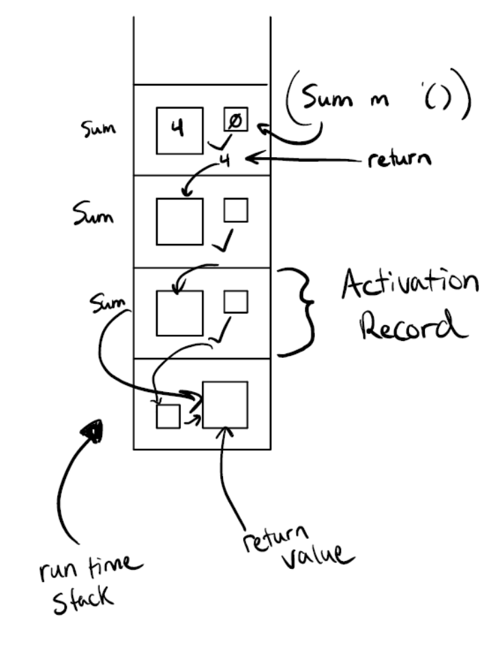

Tail Recursion (TR)
- The recursive call is the last action of a function, no additional calculation is necessary
  - with TR functions, this implies that the return from recursive call with be returned to the previous caller directly.
- No need to keep stack frame (also called activation record) for all the function calls, just the last one, thus reducing the stack space used.

;; Recursive part - private (sorta) function with additional argument to facilitate TR
;; Keep a running total → curSum
(define sumTR1
(lambda (L curSum)
(cond ( (null? L) curSum)
( else (sumTR1 (cdr L) (+ curSum (car L)) )
)))

;; interface version – user does not need to know the implementation detail
(define sumTR
(lambda (L) (sumTR1 L 0)))

Try it yourself!
1. Complete the following function for Fibonacci
1 1 2 3 5 8 13 21 34 55 89 144 233 377 610 987 1597 …..

(define fib
(lambda (n)
(cond ( (<= n 2) 1) ;; base case ;; n<=2
(else ( + (fib (- n 1)) (fib (- n 2))))) ;; fib(n-1)+fib(n-2)

Obviously, this is inefficient: https:
//willrosenbaum.com/teaching/2021s-cosc-112/notes/recursive-fibonacci/

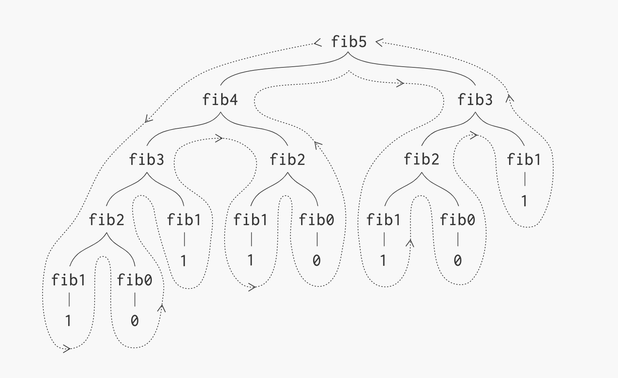

How to make this more efficient:
    - Tail recursion with scheme
    - Memoization (dynamic programming)
    - Tabulation (also dynamic programming)

Reworking the Fibonacci function using Tail Recursion

- Pass the previous two values as arguments
- N is a count of the number of steps remaining, which reduces with each call

;; interface
(define fibTR
(lambda (n)
(cond ( (<= n 2) 1)
(else ( fibTR1 (- n 2) 1 1)))))

(define fibTR1
(lambda (N f1 f2) ;; f1 and f2 are the values so far
(cond ( (zero? N) f1)
(else (fibTR1 (- N 1) (+ f1 f2) f1)))))

More about Tail Recursion
- TR is very much like iteration, except
- Intermediate values are passed as argument

Solving fib sequence with Dynamic programming
      - Memoization
      - Tabulation

See fib.cpp

Expanding to nested list

sumAll – return the total of all numbers in the list including those in sublists
(define sumAll
(lambda (L) ;; could also name the argument List, but not list
(cond ((null? L) 0) ;; base case
( (list? (car L))
(+ (sumAll (car L)) (sumAll (cdr L))))
( else (+ (car L) (sumAll (cdr L)) )))
)
)

List processing

Scheme Examples – defining our own member function
(iMember ‘c ‘(a b c d)) → (c d)
(iMember ‘a ‘( b c d)) → #f

L = (a b c d)

(car L) → a
(cdr L) → (b c d)

Base case: when L is empty
What do we return? #f

(iMember e ‘()) → #f

Recursive case: When L is NOT empty
What do we do?

Check to see if the ele is equal to (car L)
If yes, return L
else recursive call with the element and the (cdr L)

(define iMember
(lambda (e L)
(cond ( (null? L) #f )
( (equal? e (car L)) L) ;; first element match
(else (iMember e (cdr L))))))

;; how do we extend this to check membership in sublist, sort of like inList ?

>(inList e L) → #t if e is somewhere in the list, including any of the sublist, #f otherwise

;; in addition to comparing e with (car l), we need to check to see if (car l) is a list
if car is a list, then return
(or (inList e (car L)) (inList e (cdr L)))
If (car l) is not a list, proceed as normal

If we found e match some (car l), instead of return L, we return #t

(define inList
(lambda (e L)
(cond ( (null? L) #f )
( (equal? e (car L)) #t) ;; first element match
( (list? (car L)) (or (inList e (car L)) (inList e (cdr L))))
(else (inList e (cdr L))))))
Try it yourself

HW1D question 1 - Define our own reverse function, call it iReverse.

>(iReverse ‘(a b c d)) → (d c b a)

L = (a b c d)

(car L) → a
(cdr L) → (b c d)

Base case: when L is empty
What do we return? L

Recursive case: When L is not empty
How do we describe the return value?

Get cdr reversed: (iReverse (cdr L)) → (d c b)

(snoc (car L) (iReverse (cdr L)))

What if we want to reverse everything, including sublist?

There is no difference if (car L) is not a list

Add another condition for the situation when (car L) is a list

L: (a b c d) → (b c d) → (c d) → (d) → ()
Result: () → (a) →(b a) → (c b a) → (d c b a)

Try iAppend

(iAppend ‘(1 2 3) ‘(a b c)) →
(define iAppend
(lambda (L1 L2)
(cond ((null? L1) L2)
(else (cons (car L1) (iappend (cdr L1) L2))))))

HW1D question 2 – reverseAll
;; reverse everything including the sublist

(define (reverseAll L)
(cond ((null? L) L)
((list? (car L)) (append (reverseAll (cdr L)) (list (reverseAll (car L)))))
(else (append (reverseAll (cdr L)) (list (car L))))
)
)
Define total function
Argument: a list of numbers with sublists of numbers
Return: sum of all numbers in the list, including those in sublists
Ex., (total ‘(1 2 (3 () 0) 9 8))) → 23

How to break it down?

(define total
(lambda (L)
(cond ( (null? L) 0)
( (list? (car L))
(+ (total (car L)) (total (cdr L)))
( else (+ (car L) (total (cdr L))))))
)

Selected material from Chapters 3-9 of the scheme book

5.5 Iteration, etc.

Do loop
Form:
(do
( (result init_value)
(var1 init-value1 new-value1) (var2 init-value2 new-value2) …)

(test result) ;; the loop is terminated when test is TRUE

exp1 exp2 … ;; loop body - result is often updated here
) ;; end of do

Returns: last value of result

for (var1=init-value1, var2=int-value2,…. ; !test ; var1=new-value1,var2=new-value2,….)
{
exp1
exp2
…
}
return result;

;; doReverse – loop version
(define doReverse
(lambda (L)
(do ( (Lst L (cdr Lst) )
(result ‘() (cons (car Lst) result) ) )
( (null? Lst) result))
;; empty loop body
)
)
)

Operations on objects:

6.1 More type predicates

number?
Real?
Complex?
(complex? 7+5i) → #t
Rational?
(rational? 2-3i) →#f
Real?
Symbol?
(symbol? ‘aaa) → #t
(symbol? “a”) →#f
Procedure?
Negative?
Even?
Odd?
Remainder
(remainder 10 7) →
(remainder –10 7) →
Quotient,
(Truncate 3.2) → 3
(Floor 3.2) → 3

Do truncate and floor always evaluate to the same?

Ceiling, round, max, min
gcd (greatest common denominator, always nonnegative)
(gcd 19 57 361) →19
expt, sqrt,

7.1 Input Operations
(read) – read input from default input-port (e.g., keyboard) and returns its value.
Ex., (read)
How do we read value into variables?

(read input-port) – read from specified input-port
Ex.,
(let ((
(open-input-file “example.scm”)) ;; open and returns its port
(var “something”))
(set! var (read porter)) var)

7.2 Output operations
(write obj) or (write obj port)
(display obj) or (display obj port) – print strings and symbols without “” or ‘

(newline) or (newline port)

Another example with sublist

Largest – accept a list and returns a list with the largest number from the list including sublist

Example list: ((4 5) (2 (3 0) 1 (9))) → ‘(9)

Algorithm:

Use recursion,

Base case:
when the List is empty, return ‘()
when the list has one element, return it

Recursive case:

; start with the car

Another example:

Write a function to replace every g in a list with good.

Ex., L = (g gg ggg u f g asfd ewre gfd)

(replaceG L) -> (good gg ggg u f good asfd ewre gfd)

(car L) -> g
(cdr L) -> (gg ggg u f g asfd ewre gfd)

Add ;; cons
(car L)==g? good: (car L)
To beginning of
(replaceG (cdr L)) → (…)

(define L '(g gg ggg u f g asfd ewre gfd))

;; replace every occurrence of O with R
(define replaceG
(lambda (L O R)
(cond ((null? L) L) ;; base case - L is null
((equal? (car L) O) (cons R (replaceG (cdr L) O R))) ;; recursive case 1
(else (cons (car L) (replaceG (cdr L) O R))) ;; default case
) ;; end of cond
) ;; end of lambda
) ;; end of define

;; replace every occurrence of O with R, including sublist
(define replaceAll
(lambda (L O R)
(cond ((null? L) L) ;; base case - L is null
((equal? (car L) O) (cons R (replaceAll (cdr L) O R))) ;; recursive case 1
((list? (car L)) (cons (replaceAll (car L) O R) (replaceAll (cdr L) O R)))
(else (cons (car L) (replaceAll (cdr L) O R))) ;; default case
) ;; end of cond
) ;; end of lambda
) ;; end of define
PLP10.3.6 DFA simulation

Input:
- A DFA description
- Input stream (ex., a list of the alphabets in the domain)

Output:
- Accept/reject !!!!
- Final state?
- Sequence of states? !!!!

HW1G

Draw a DFA on alphabet {0,1} that accepts any stream with even number of 0s and 1s.
Input: 010010 → yes
Input: 00000 → No

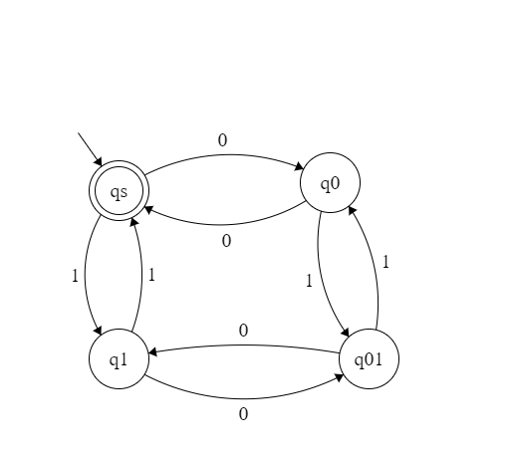

How would you describe this particular DFA in C++?
We could use a graph, implemented with a adjacency matrix

Qs q0 q1 q01
 | 0 | 1
0 |  |  | 1
1 |  |  | 0
 | 1 | 0

How do we store any DFA with C++?
A vector of nodes: vector<nodeType> nodes;
The adj matrix: vector<vector<char>> edges;

How do we store them in scheme?

Use a list: (startState, transitionF, finalStates)
Atom Asso list list
How do we represent transition function in Scheme?
Use association list

See dfa.rkt

